Pump

A **pump** is a device that moves fluids ([liquids](https://en.wikipedia.org/wiki/Liquid) or [gases](https://en.wikipedia.org/wiki/Gas)), or sometimes [slurries](https://en.wikipedia.org/wiki/Slurry), by mechanical action.

**Pumps** can be **classified** into three major groups according to the method they use to move the fluid: direct lift, displacement, and gravity **pumps**.

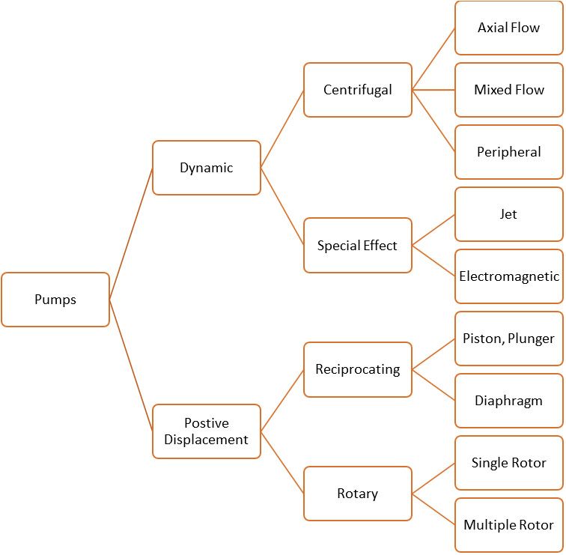

Screw pump:

A **screw pump** is a **type** of rotary **pump** which is equipped with **screws** that mesh together and rotate within a cylindrical cavity or liner. The fluid enters from the suction side of the **pump** and moves linearly along these intermeshing **screws** to the discharge side of the **pump**.

Types of screw pump:

1) One screw pump

A screw pump is a positive-displacement (PD) pump that use one or several screws to move fluids or solids along the screw(s) axis. In its simplest form (the **Archimedes' screw pump**), asingle screw rotates in a **cylindrical** cavity, thereby moving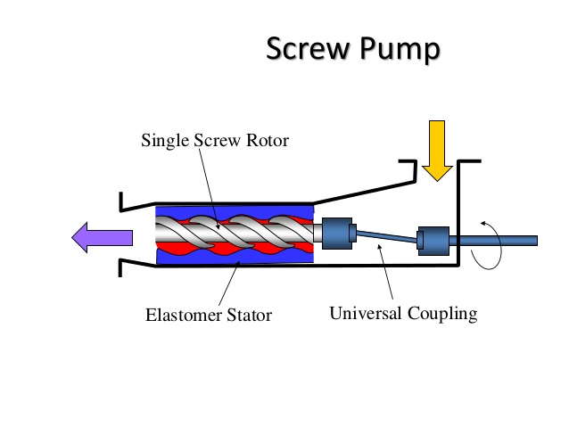

2)Two screw pump:

The two screw pump also known as the twin screw pump is the most common type for high power application such as heavy oil pipeline transfer.one of the screw os driven from the power source (motor engine) and timing gears usually incorporated to rotate the second screw.

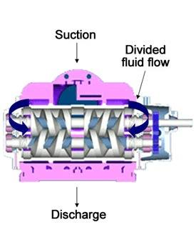

3)Three screw pump:

The three screw pump also known as the triple screw pump is typically used for small applications such as lubrication systems.one of the screw is driven from the power source which then rotates the other two screw around it without the use of timing gears.

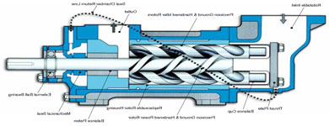

**Applications for Screw Pumps:**

Due to their ability to provide high flow rates even in viscous liquids, screw pumps are ideal for fuel transfer, elevators, and other similar industrial applications. Single screw pumps, or Archimedean screw pumps, are used for simple water movement such as for sewage inlet pumps, storm water pumping, drainage pumping, and to move industrial waste water.

**Screw Pump Application Ranges:**

* Flow Rate Ranges – 50 to 15,000 gallons per minute, 189 to 56,781 liters per minute
* Total Head (Pressure) Ranges – 50 to 4,500 psi, 3 to 310 bar
* Horse Power Ranges – 5 to 5,000

Screw pump working:

A Screw Pump is a type of Positive Displacement Pump. This means that it moves fluid by continually displacing the area that the fluid occupies. The screws are encased inside of a liner, usually made of some sort of metal. The fluid fits into the screw cavities within this liner and is forced through the pump and out of the discharge as the screws rotate and inter-mesh.

Since there needs to be some clearance between the liner and the screws, it is possible for any fluid that is pumped to slip backwards into the pump to lower pressure zones. For high viscosity fluids like this volumetric slippage is usually a non-issue.

As the viscosity decreases, however, this slippage becomes substantial thus; reducing the efficiency of the pump. This has to be taken into consideration when pumping water or similar fluid, and particularly in multi-phase applications where vapour slugs are mixed into the fluid stream. In these cases, all the clearances within the pump must be minimized to reduce slip.

When a screw pump is pumping oil or some other type of viscous fluid, the screws can intermesh closely with very little or no clearance, since the surfaces are being lubricated as the fluid is pumped. When pumping water, water/gas mixture, or some other type of light fluid, these parts can not contact each other, else rapid wear on the parts will occur. For this reason, a three screw pump, (where one screw drives the other two screws without the use of timing gears) should never be used for water service or multi-phase service.

In the case of a triple screw pump, shaft seals are only needed on the driving rotor. The other rotors, including their bearings, are encased inside the pumping chamber and do not protrude out. In the case of a two screw pump or a four screw pump, both rotors generally protrude through the pump case, into a gear case where the timing gears are housed. For this reason, four shaft seals are needed in a screw pump with two rotors.

Products:

ROTARY POSITIVE DISPLACEMENT PUMPS AND ACCESSORIES

We manufacture the following:

* Progressive Cavity Pumps
* Twin Screw Pumps
* Triple Screw Pumps
* Internal Gear Pumps
* External Gear Pumps
* Internal Lobe Pumps
* External Lobe Pumps
* Shuttle Block Pumps
* Filters & Strainers
* Relief Valve (For Pump Overload Protection)
* Flowmeters – Vane Type & Screw Type

Company profile (Pumpsquare system llp):

Pumpsquare Systems LLP is a company manufacturing & marketing pumps, process equipments and installations. Production facility is located in VithalUdyog Nagar (near Anand), Gujarat – India.

The pumps manufactured by us include Progressive Cavity Pumps, Twin Screw Pumps, Triple Screw Pumps, Gear Pumps, Lobe Pumps, Vane Pumps, Shuttle Block Pumps as well as Thermic Fluid Pumps.

With this complete range of pumps, Pumpsquare offers to the engineers, suppliers, OEM’s and users a single source of supply for their pump requirements. The appropriate pump for each specific application and the advantage of buying their complete pump requirements from one source can lead to optimum economic solutions.

Our products are utilized throughout the world in a variety of applications such as Chemicals and Petrochemicals Industry, Naval and Offshore Applications, Hydraulic Power Applications, Water and Waste Water Sewage Disposal Applications, Lube Oil and Fuel Firing Systems, Heating and Air – Conditioning, Surface Treatments, Heavy Engineering Industry Paper and Pulp Industry, Food Industry, General Industrial Engineering and other special areas of the producing and processing industry.

This production facility, which belongs to Pumpsquare Systems LLP since 2011, employs approximately 30 people. The high quality standard which has been established by “Turakhia”, has carried on the tradition of producing quality pumps. The prerequisite of producing quality pumps is to maintain a professional staff, maintain basic and advance training for all of its personnel and a constant effort to produce uncompromising products.

Besides the positive displacement pumps, we also trade basket type strainers, flowmeters, thermic fluid pumps and Oil Lubrication & Transfer Skids or Systems.

Pumpsquare Systems LLP works covers approximately 1800 sq meters, produces and markets its complete range of pump products. The special knowledge, products as well as applications are at disposal of the entire team. Round the clock after sales services is available for all of our customerS

## RESEARCH & DEVELOPMENT

We maintain a research and development department to stay current with the ever changing requirements of new fields of applications. The job of our research team is to incorporate all the customer needs (CN) in our products.

The research enables us to improve the product design, incorporate wide variety materials of construction as well as enable us to have special pump construction & configuration.

One of the important benefits of the development is to constantly improve the quality of product being manufactured.

One of the examples is that by developing special internal lobes for pumps, it gave us a niche in the market over our competitors wherein we could supply the pumps with very high volumetric efficiency, high NPSH values, higher hydraulic efficiency, and reduction in capital cost for customer and most important is the reduction in the working cost of the pumps. Also, by improving the machining techniques, the operating level of the noise has reduced sustainably.

These improvements also contribute to keeping the cost of pump manufacturing at the minimum. The end results of the improved efficiencies is marked reducing in energy expenses and operating costs.

## PRODUCT QUALITY & ASSURANCE

The great importance which we attach to modern production at our company is particularly illustrated by the use of low cost automation devices as well as the use of CNC Machining Centers.

With a view to assuring constant quality in our products, we develop our own special tools and fixtures for production. Our research team has developed special tools for the screw profiles.

Constant monitoring of the chemical and physical properties of our casting materials and welded constructions as well as controls performed at all stages of production to ensure an uncompromising quality of products. All the pumps are exposed to running tests and must meet a minimum level of performance before final approval by our test departments. Special Tests, as required by our customers can also be performed.

We have successfully implemented ERP to track and maintain the record of the items used in our products including the sources of raw material.